# SET UP FOR API (Database first)

1. Extract here file bin&obj.rar

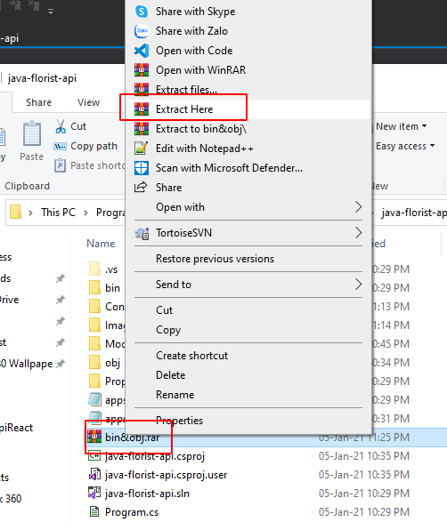

1. Create database (find script in *Material/summary.sql)*
2. Change server in appsetting.json

Remember to change server to your local server (in development process don’t commit this file to git)

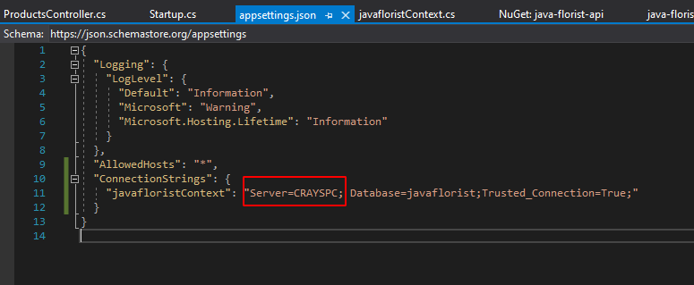

1. Build and start api

# SET UP FOR FRONT-END

After Clone in terminal cd to java-florist-react then run command *npm install* then start by *npm start*

If setup correctly, go to *http://localhost:3000* you will see something like this

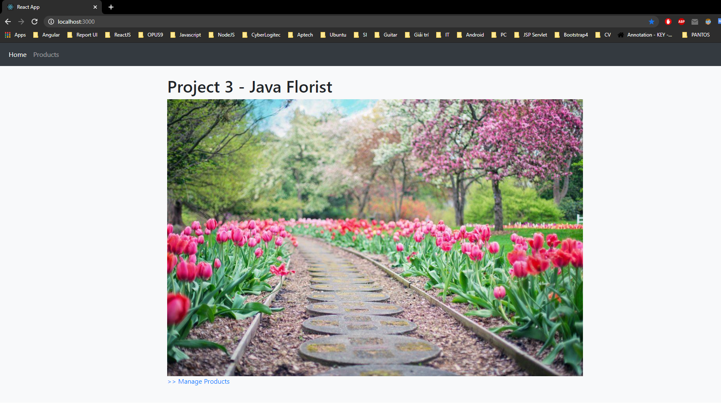

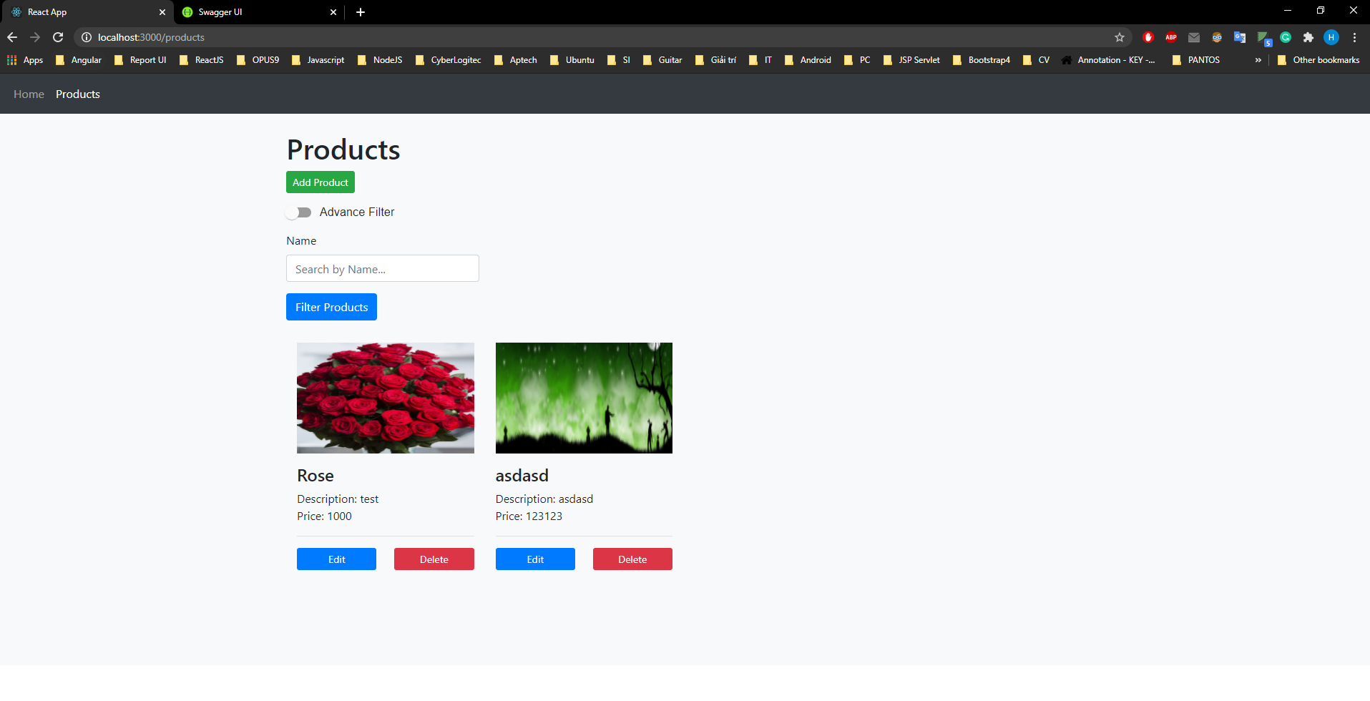

All function available in this page is worked, you can try it!

# SET UP FOR ADMIN FRONT-END

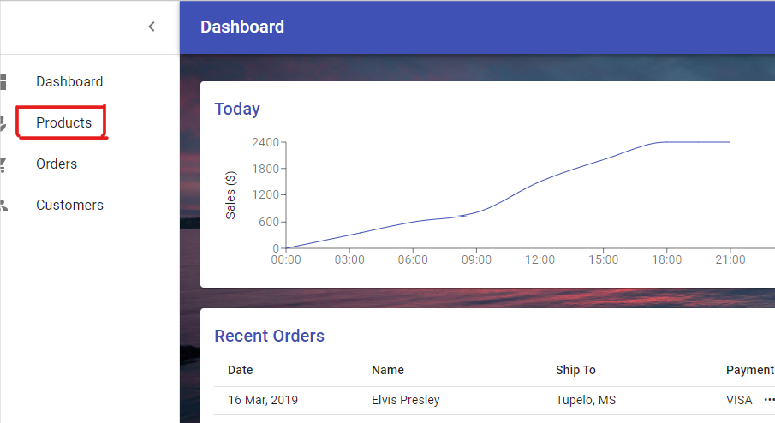

Ex: Create new Page for Product!!

**Step 1:**

Create new Component. Ex: Product.component.js

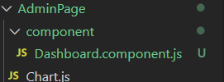

**Step2:**

Decalre new Component in Dashboard.js => mainPage() Replace null = new Component

